Class5.R

bluer

2025-01-16

x <- 1:50  
plot(x,sin(x))

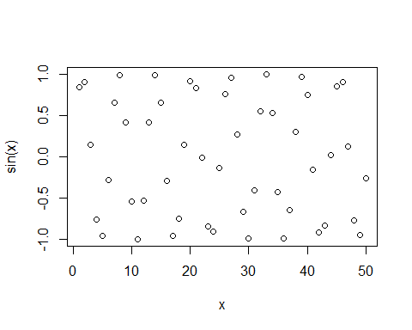

# Make this nicer  
plot(x, sin(x), col= "blue", type="l", lwd = 3)

